Carting club software

Software provides full range of operations for carting club:
- allows to add racers or select from list of exist racers;
- works with AMB20 device and sensors installed on karts for collect statistic info about lap times;
- allows to have few tracks and stores lap time, best result for each track;
- stores payment operations, creates reports about it;
- shows advertisement images on additional display,
- etc.

Software developed by other programmer. My participation:
- DB server changed from MySQL to MSSQL due to low performance of software;
- Fixed DB structure (due to absence of relationships program allows to delete data from which depended other data);
- in-code defined “hard” SQL queries replaced by stored procedures;
- fixed algorithms for best time result definition;
- fixes in sensors detection algorithm;
- added export of racers to Excel file;
- possibility to show images on additional display (sponsors or kart club owner images);
- added discount cards operations

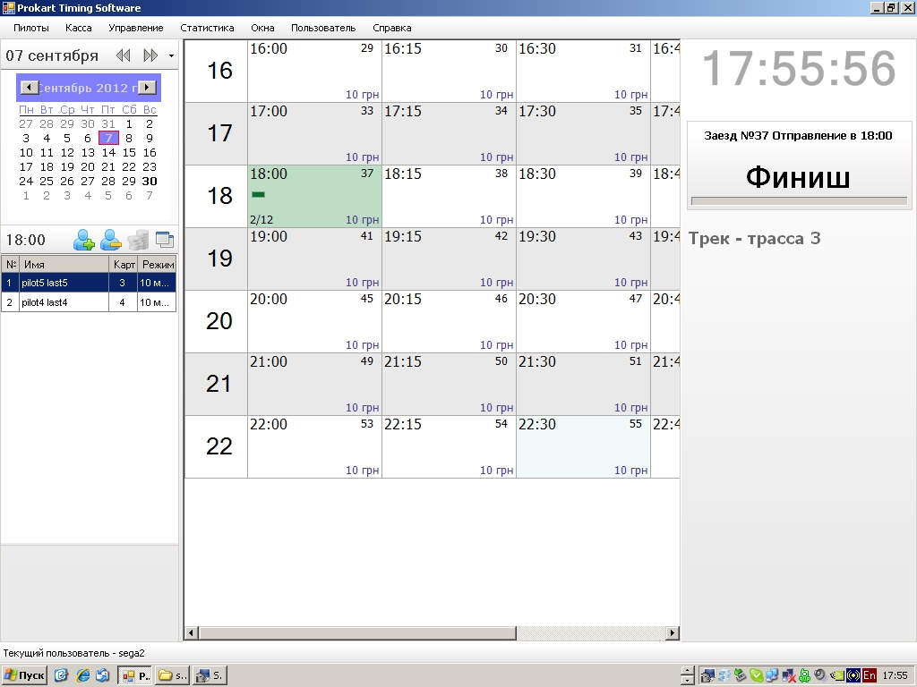
1. main form

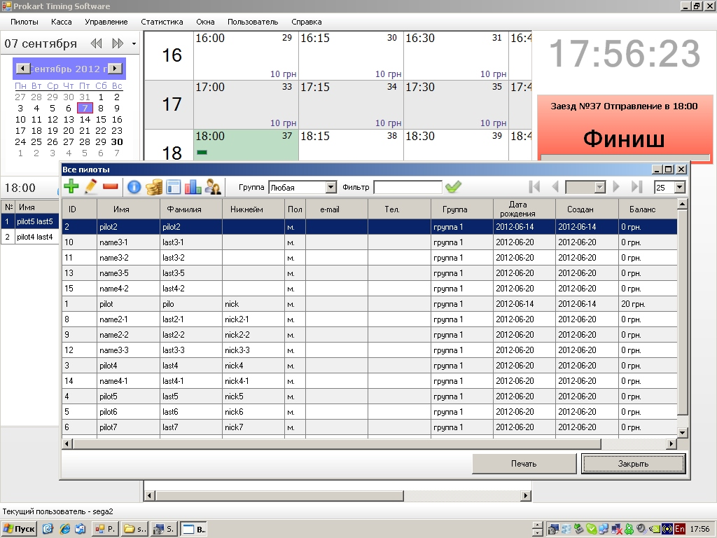
2 racers list

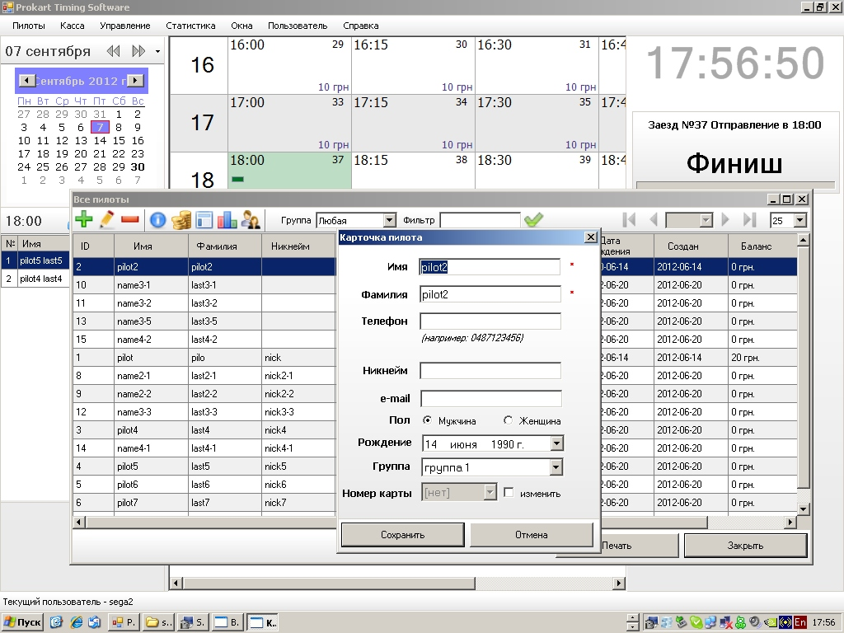
3. add racer form

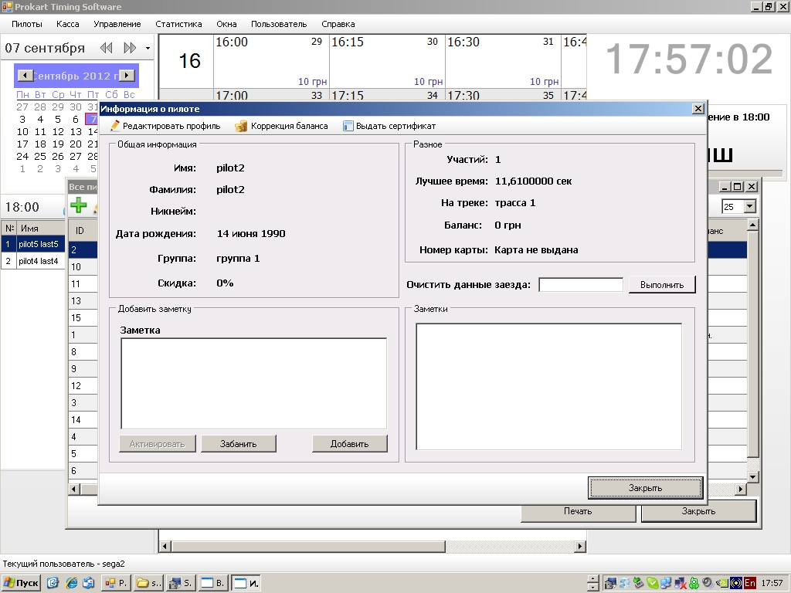
4. racer details

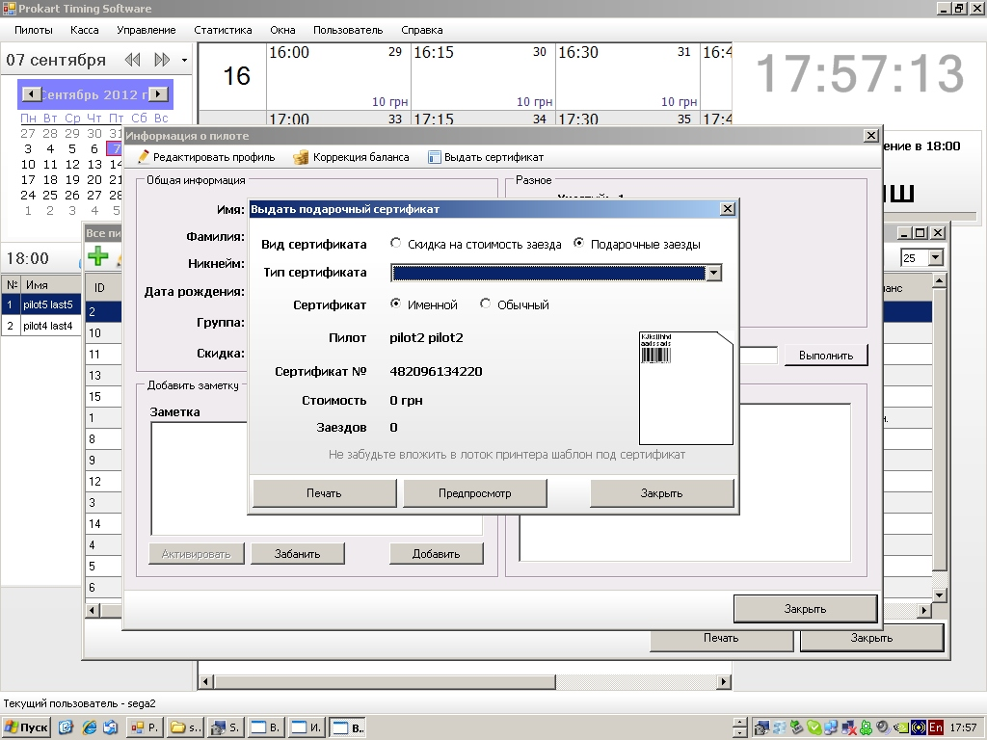
5. gift certificate

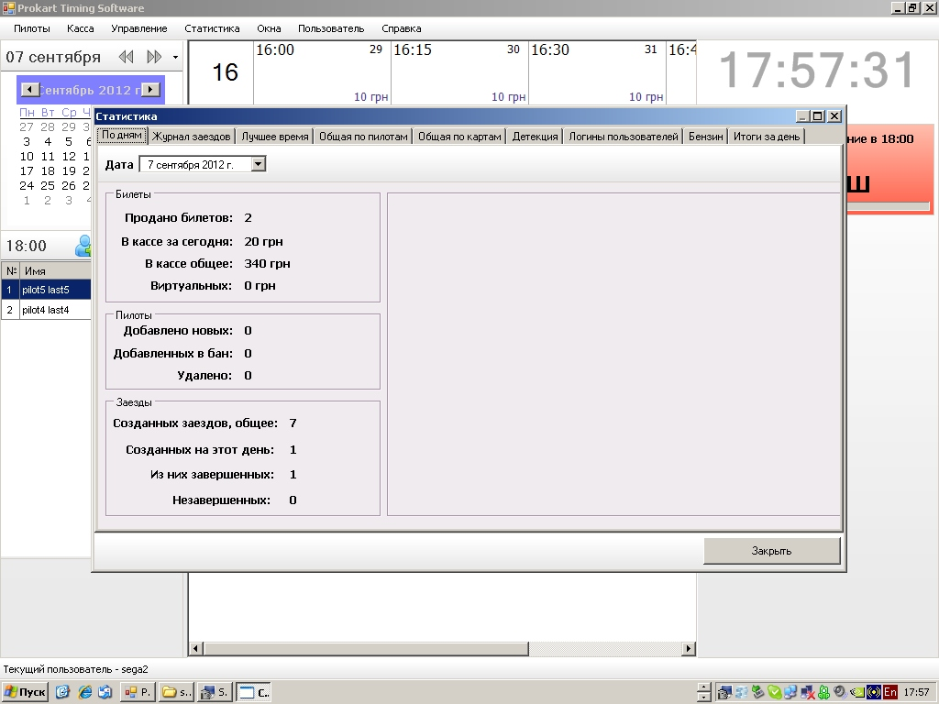
6. daily statistic

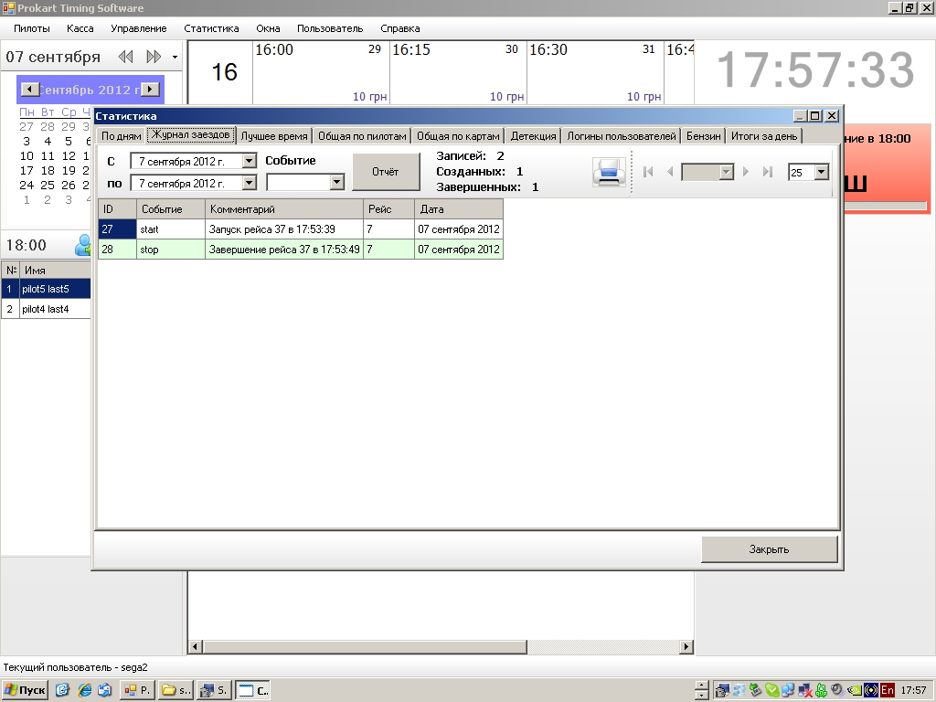
7. history of races
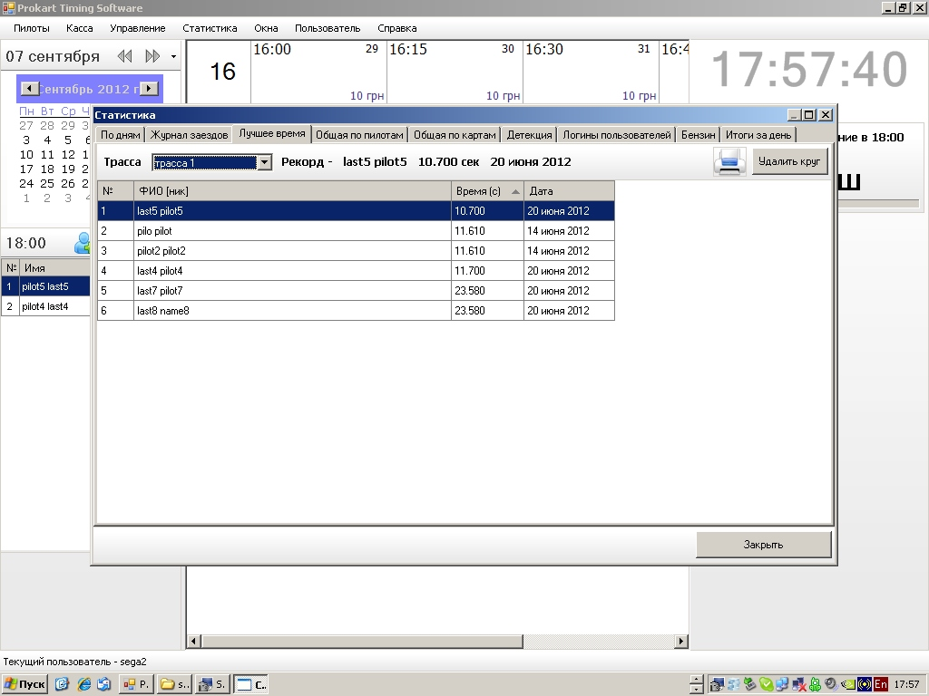
8. best race time

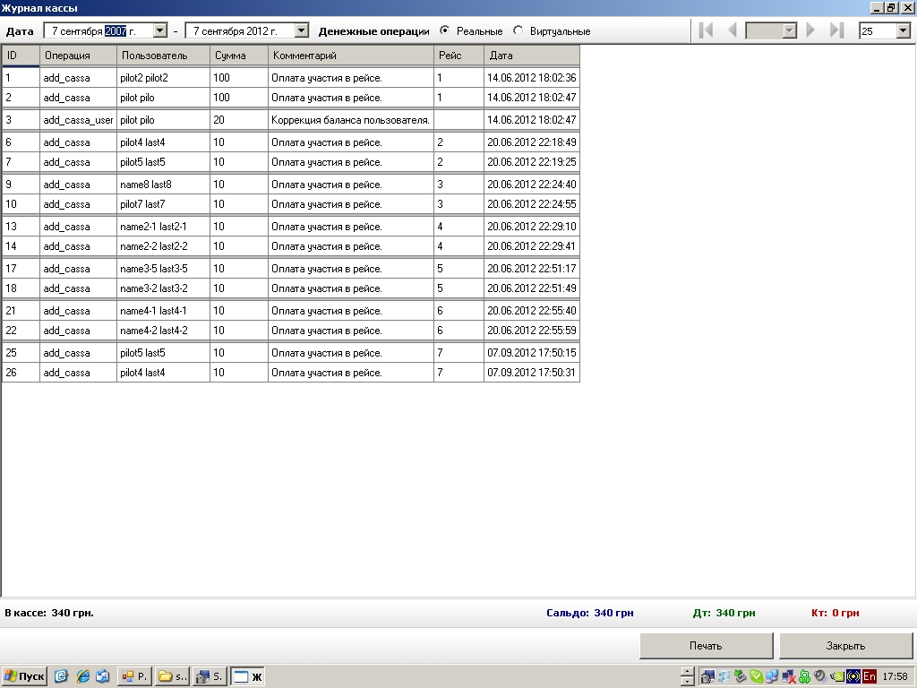
9. cash operations

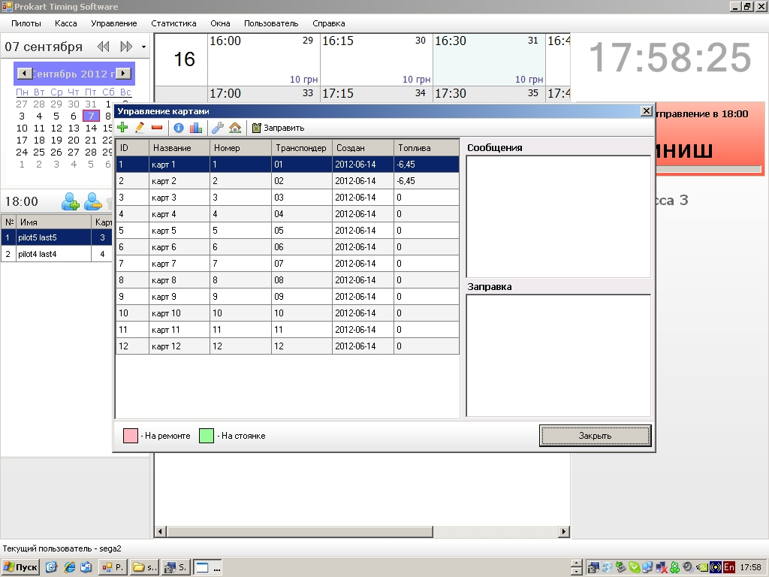
10. karts / sensors list

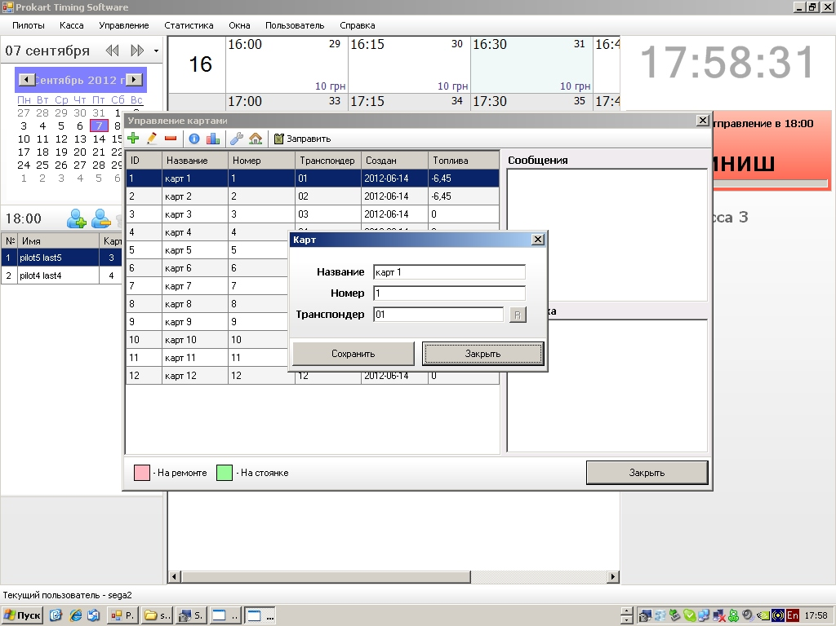
11. edit kart form

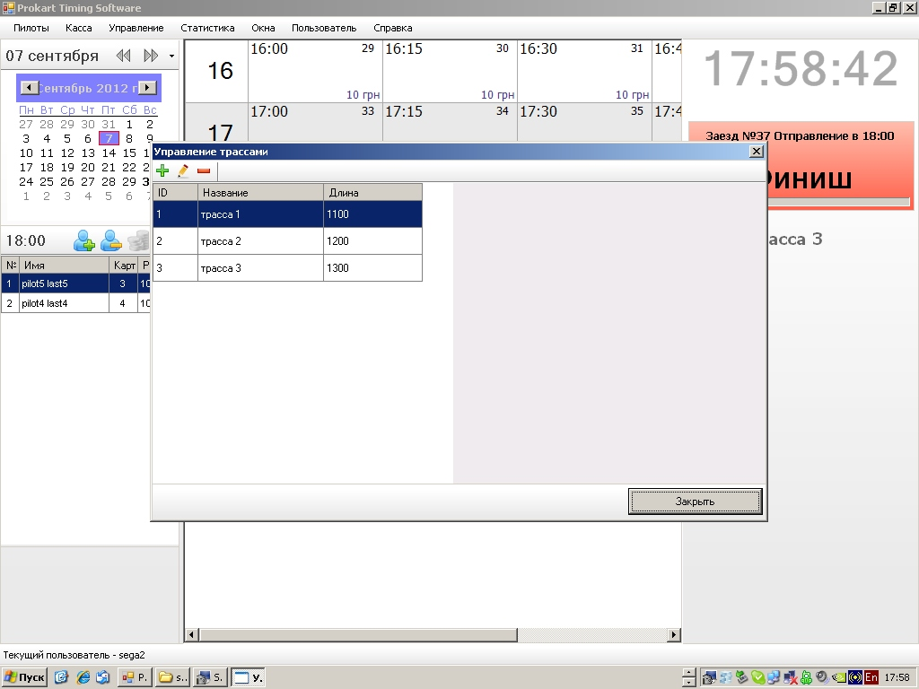
12. tracks list

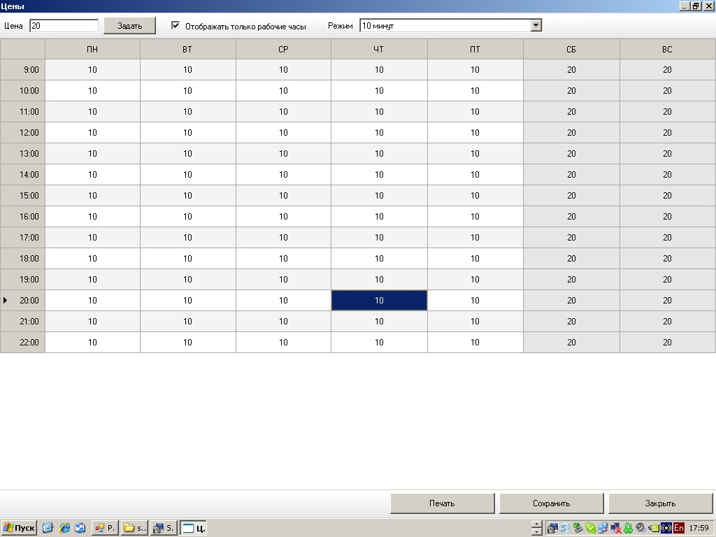
13. tariffs for different days and time of the day

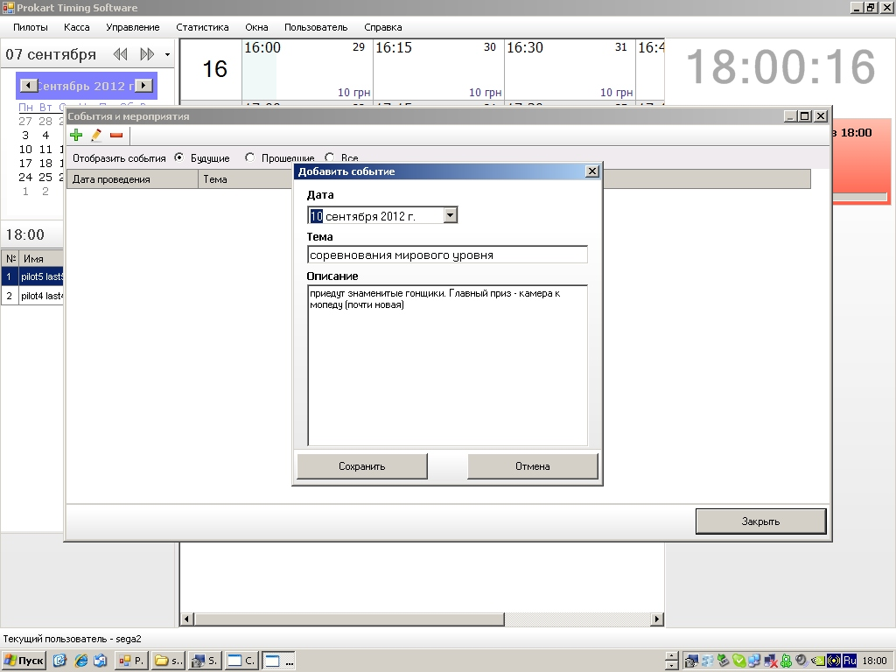
14. add event form

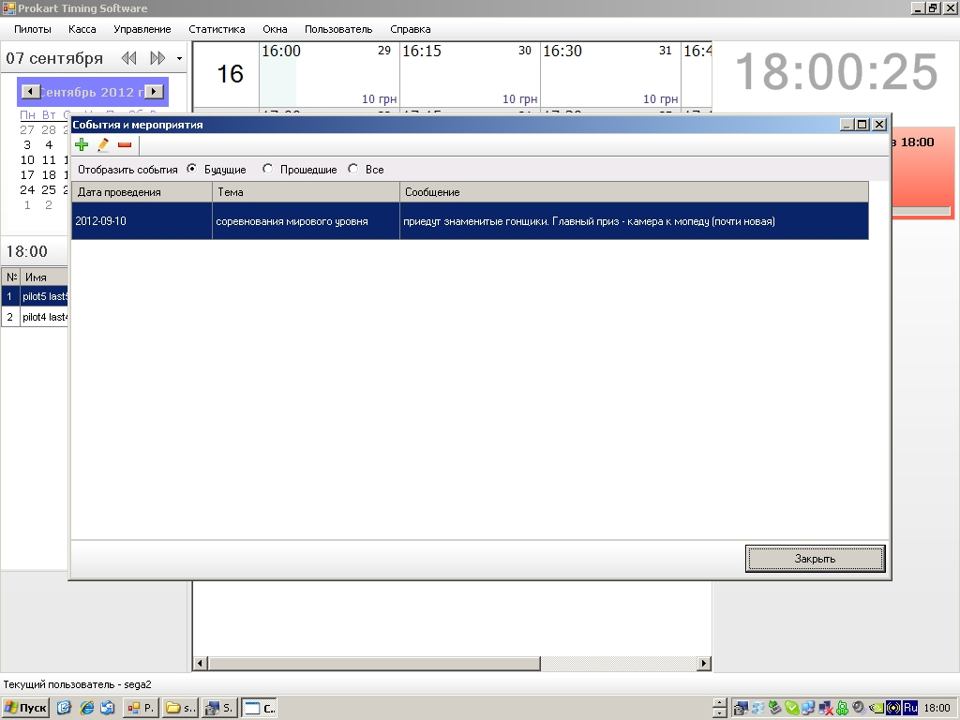
15. events list

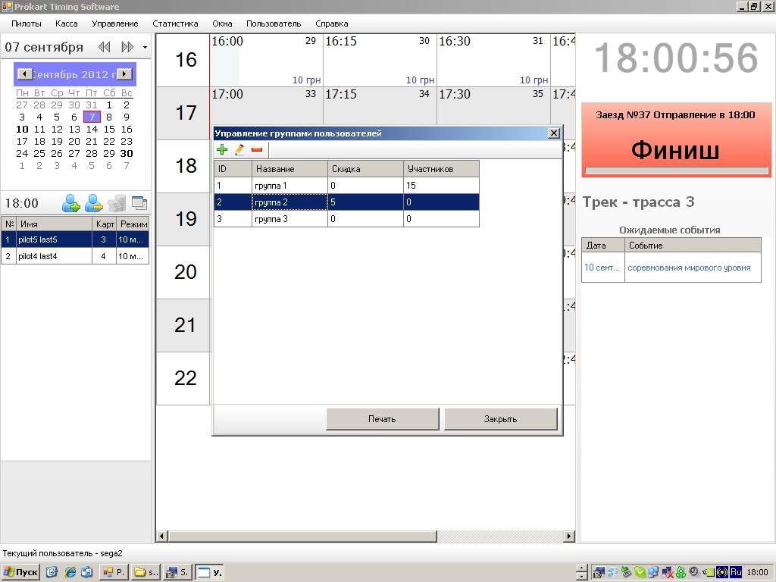
16. user groups

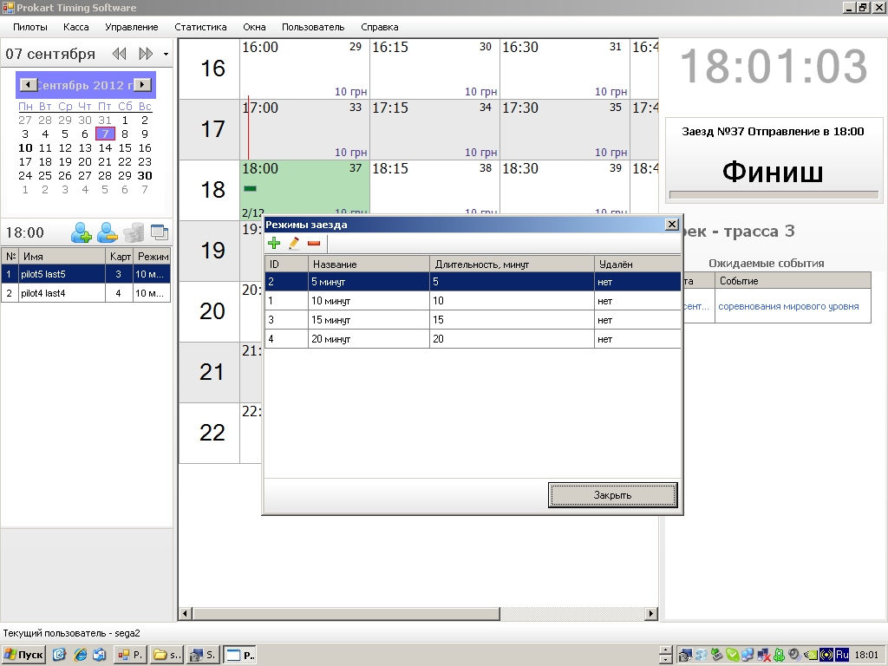
17. race modes

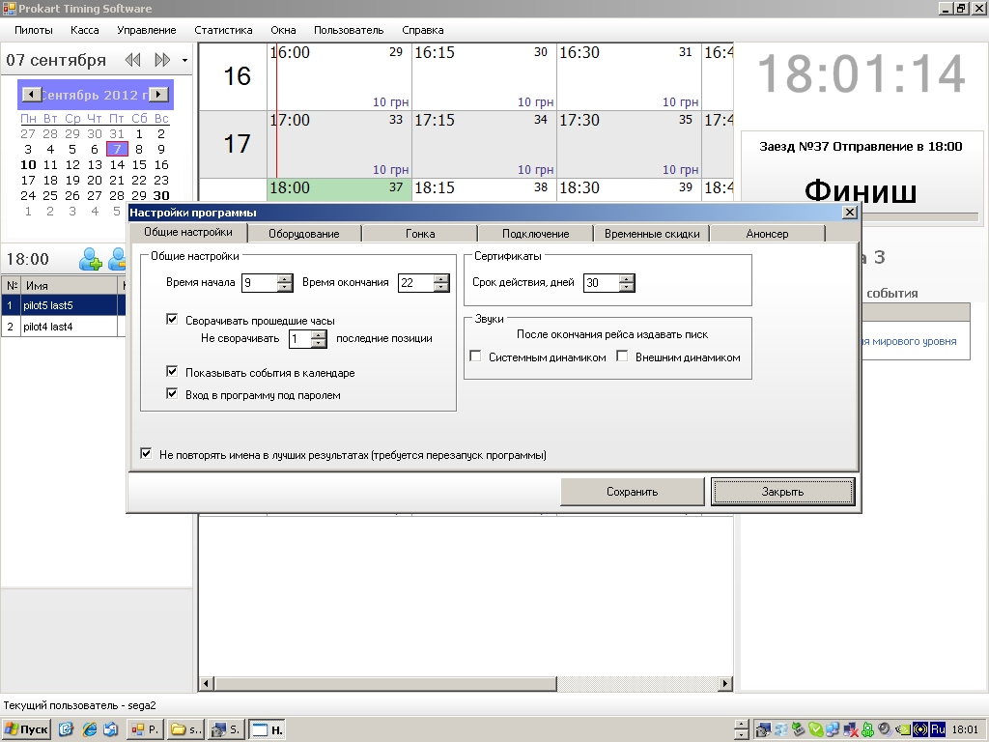
18. general settings

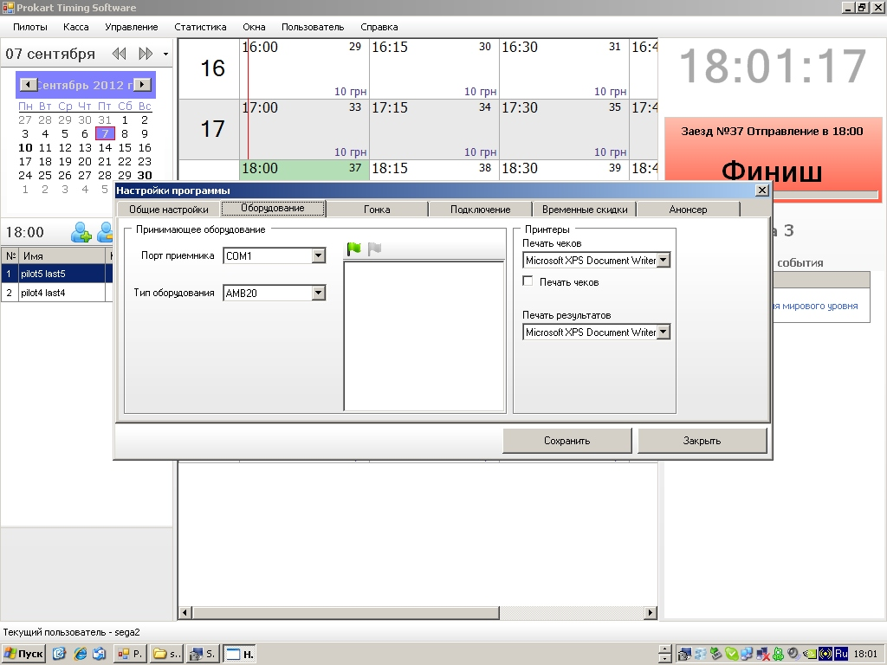
19. equipment settings

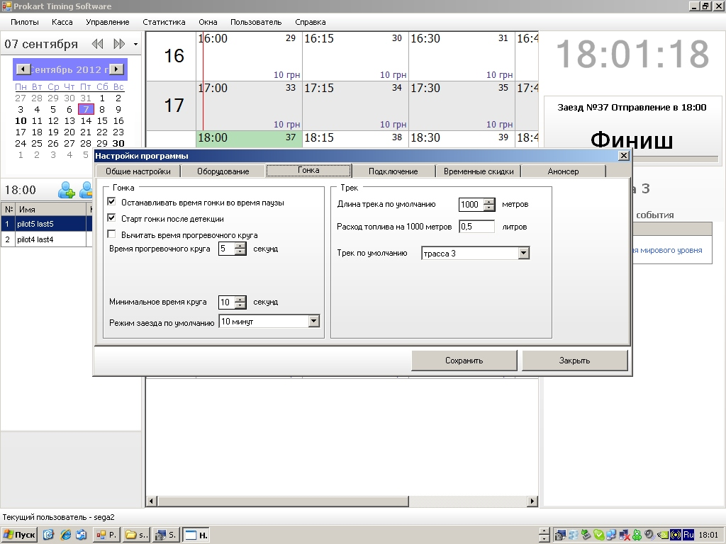
20. race settings

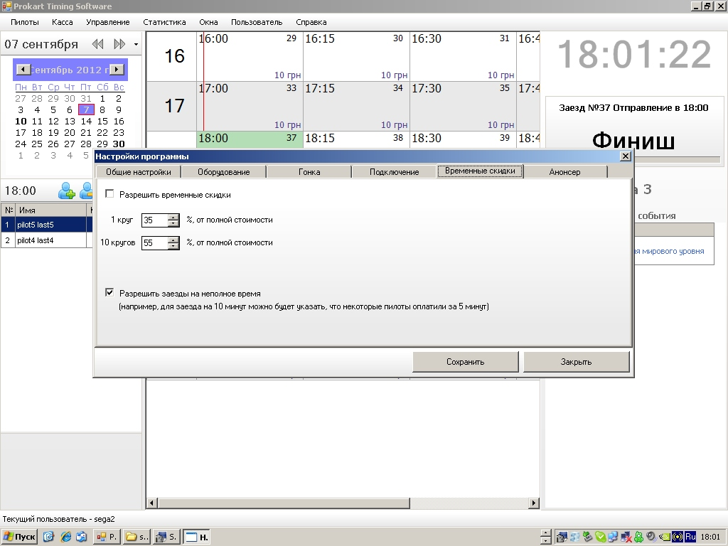
21. time discount parameters

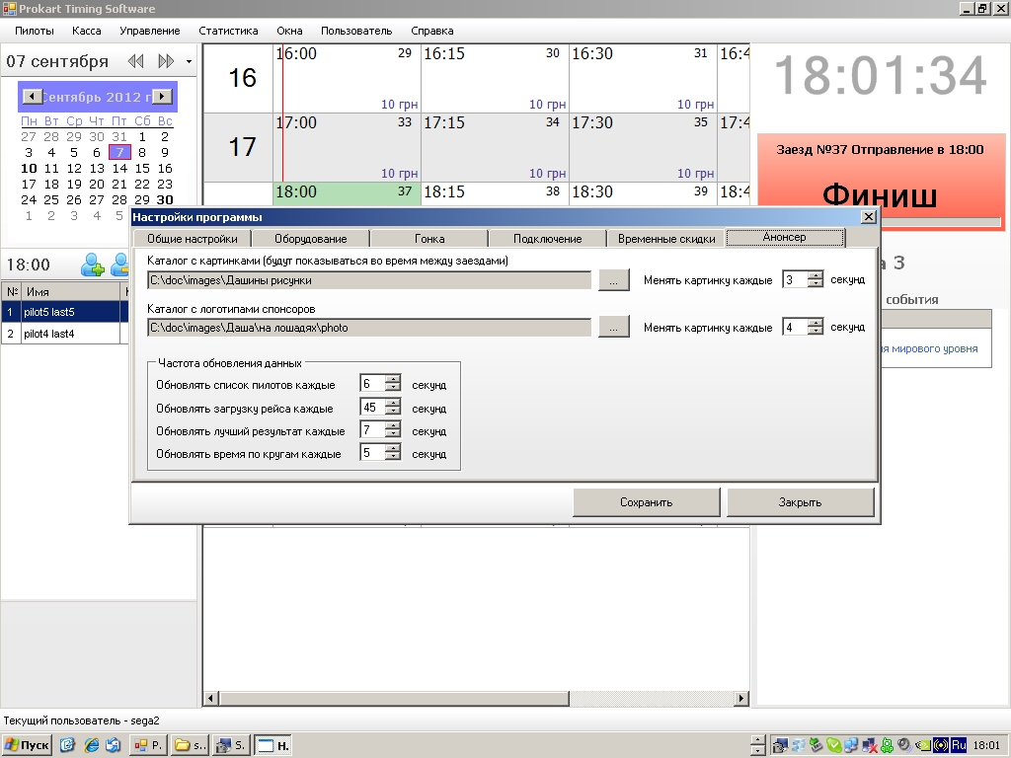
22. announcer settings (for show useful information on additional display)
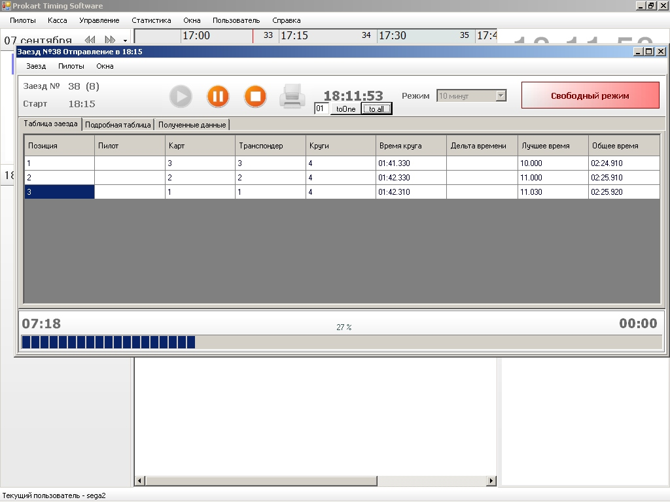
23 race has been started...

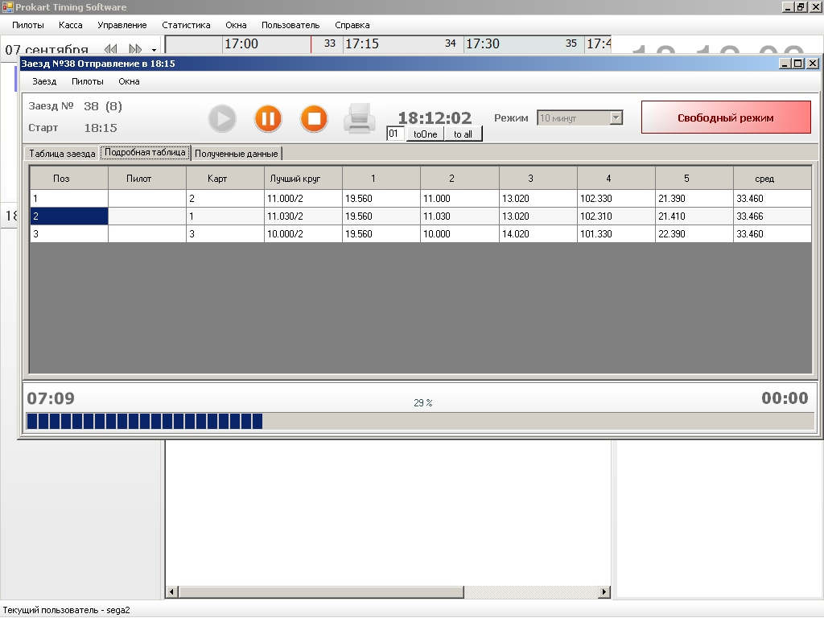
24. after few laps

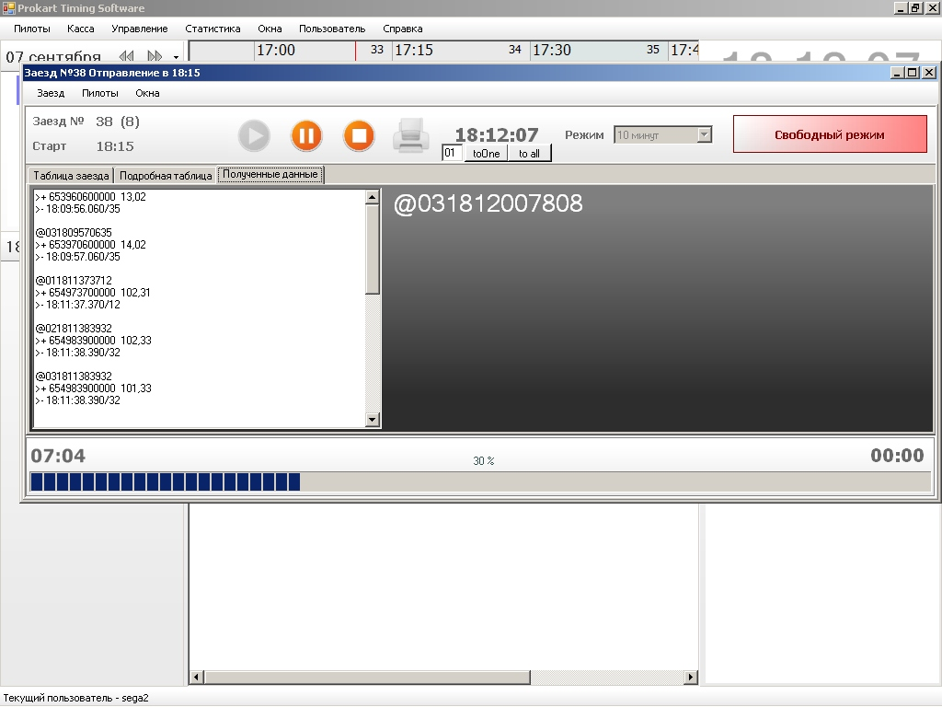
25. log of AMB20 device and driver

